Digitalocean

instance creation

using SSH key-gen

from base machine

#ssh-keygen

id_rsa id_rsa.pub

copy the public key in to digitalocean when ssh key asking

and after creation of instance

#ssh -i id_rsa(privatekey) root@public ip

then access username as root

otherway access ssh auto login

direct we can access #ssh hostname

ie ssh digi

#nano .ssh/config

Host digi
Hostname 139.59.11.180
user root
port 22
IdentityFile /home/ubuntu/digi123

then we can access

just

#ssh digi directly is connected to the instance

using putty

take putty key generator

click on genarate key

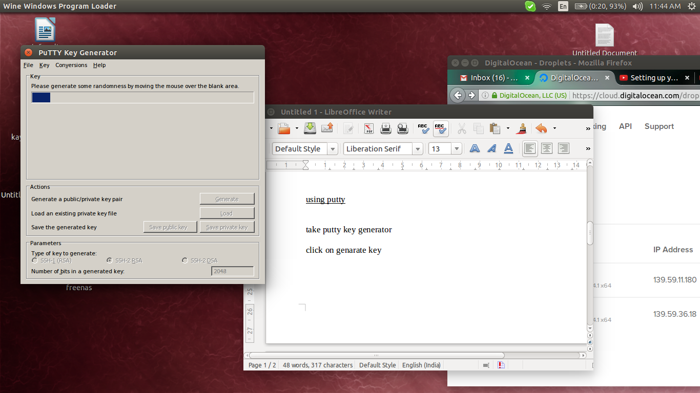

copy the public key in to ssh key creattion

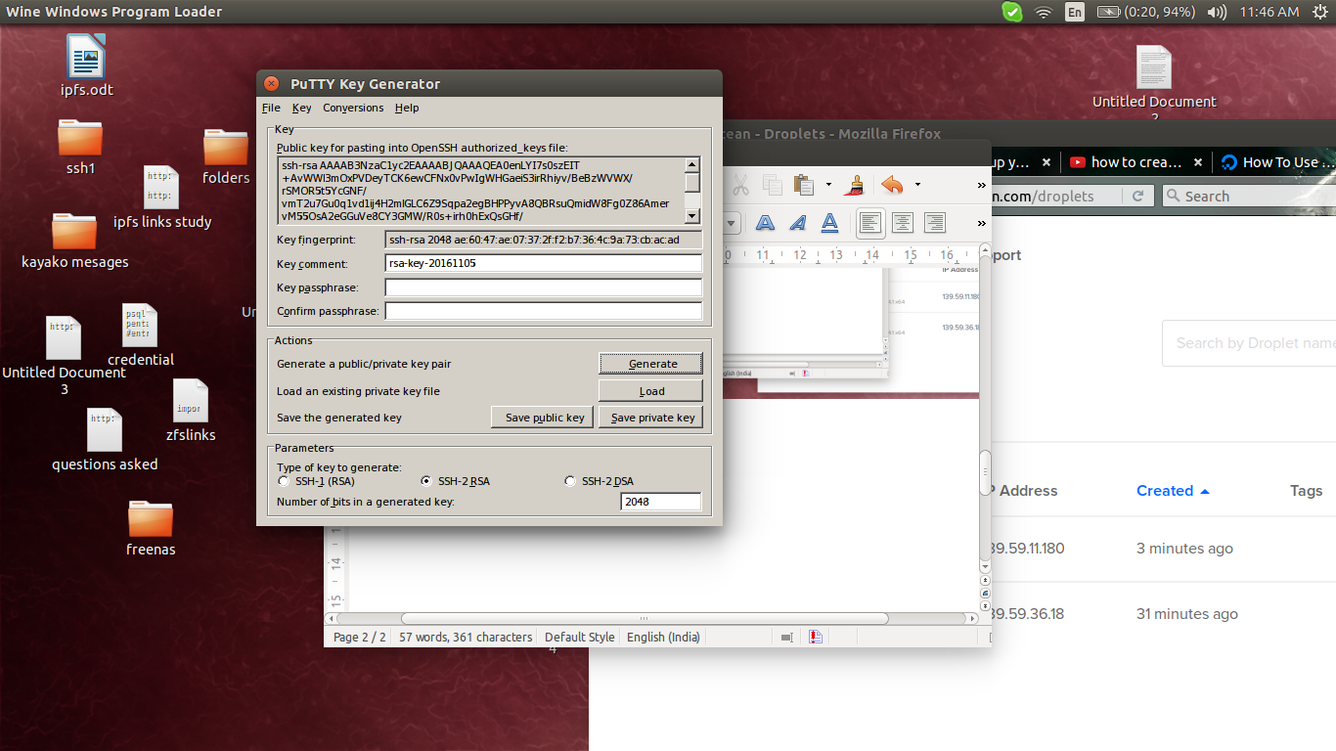

and save as private key

.ppk file
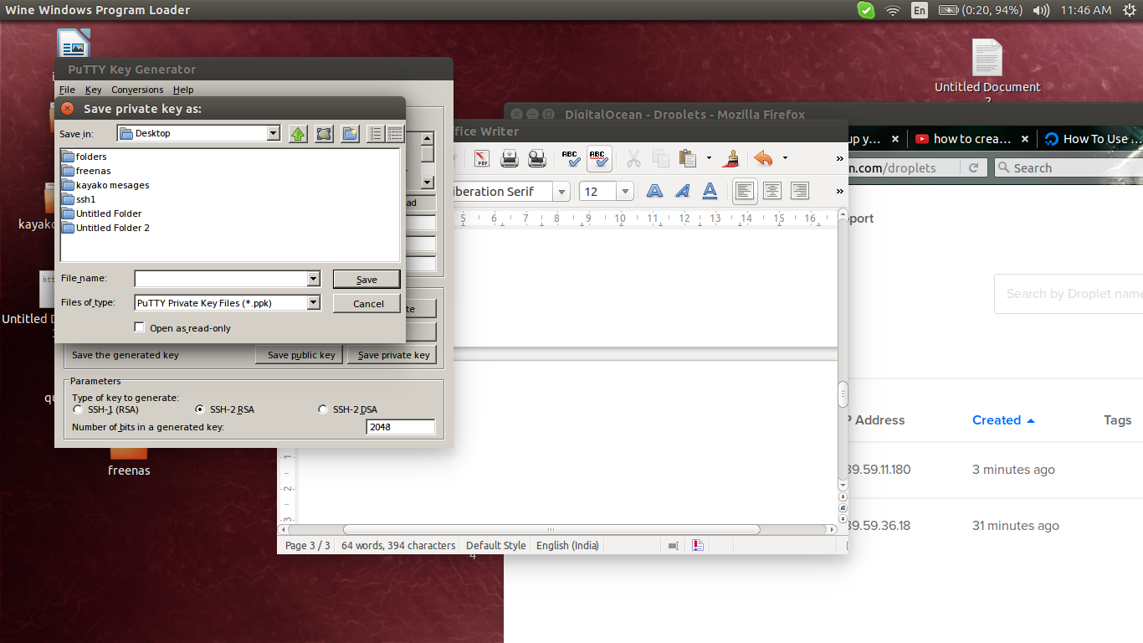

for connection take putty ssh client

give the ip

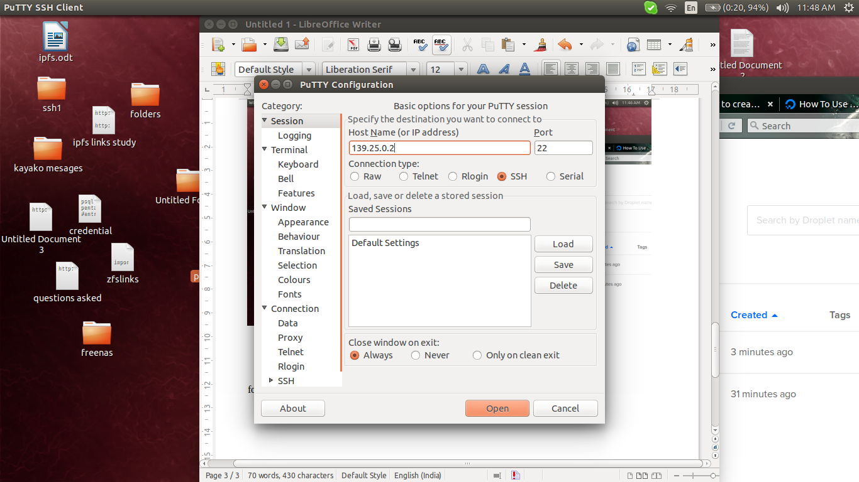

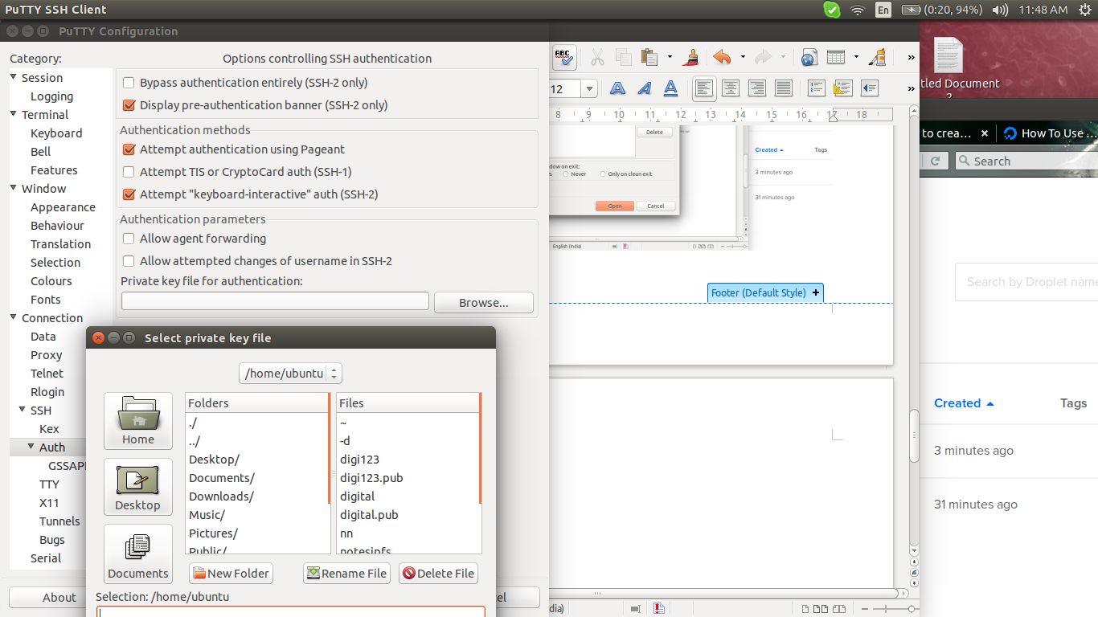

give the .ppk file to that

and access click open

give the first user name as root

